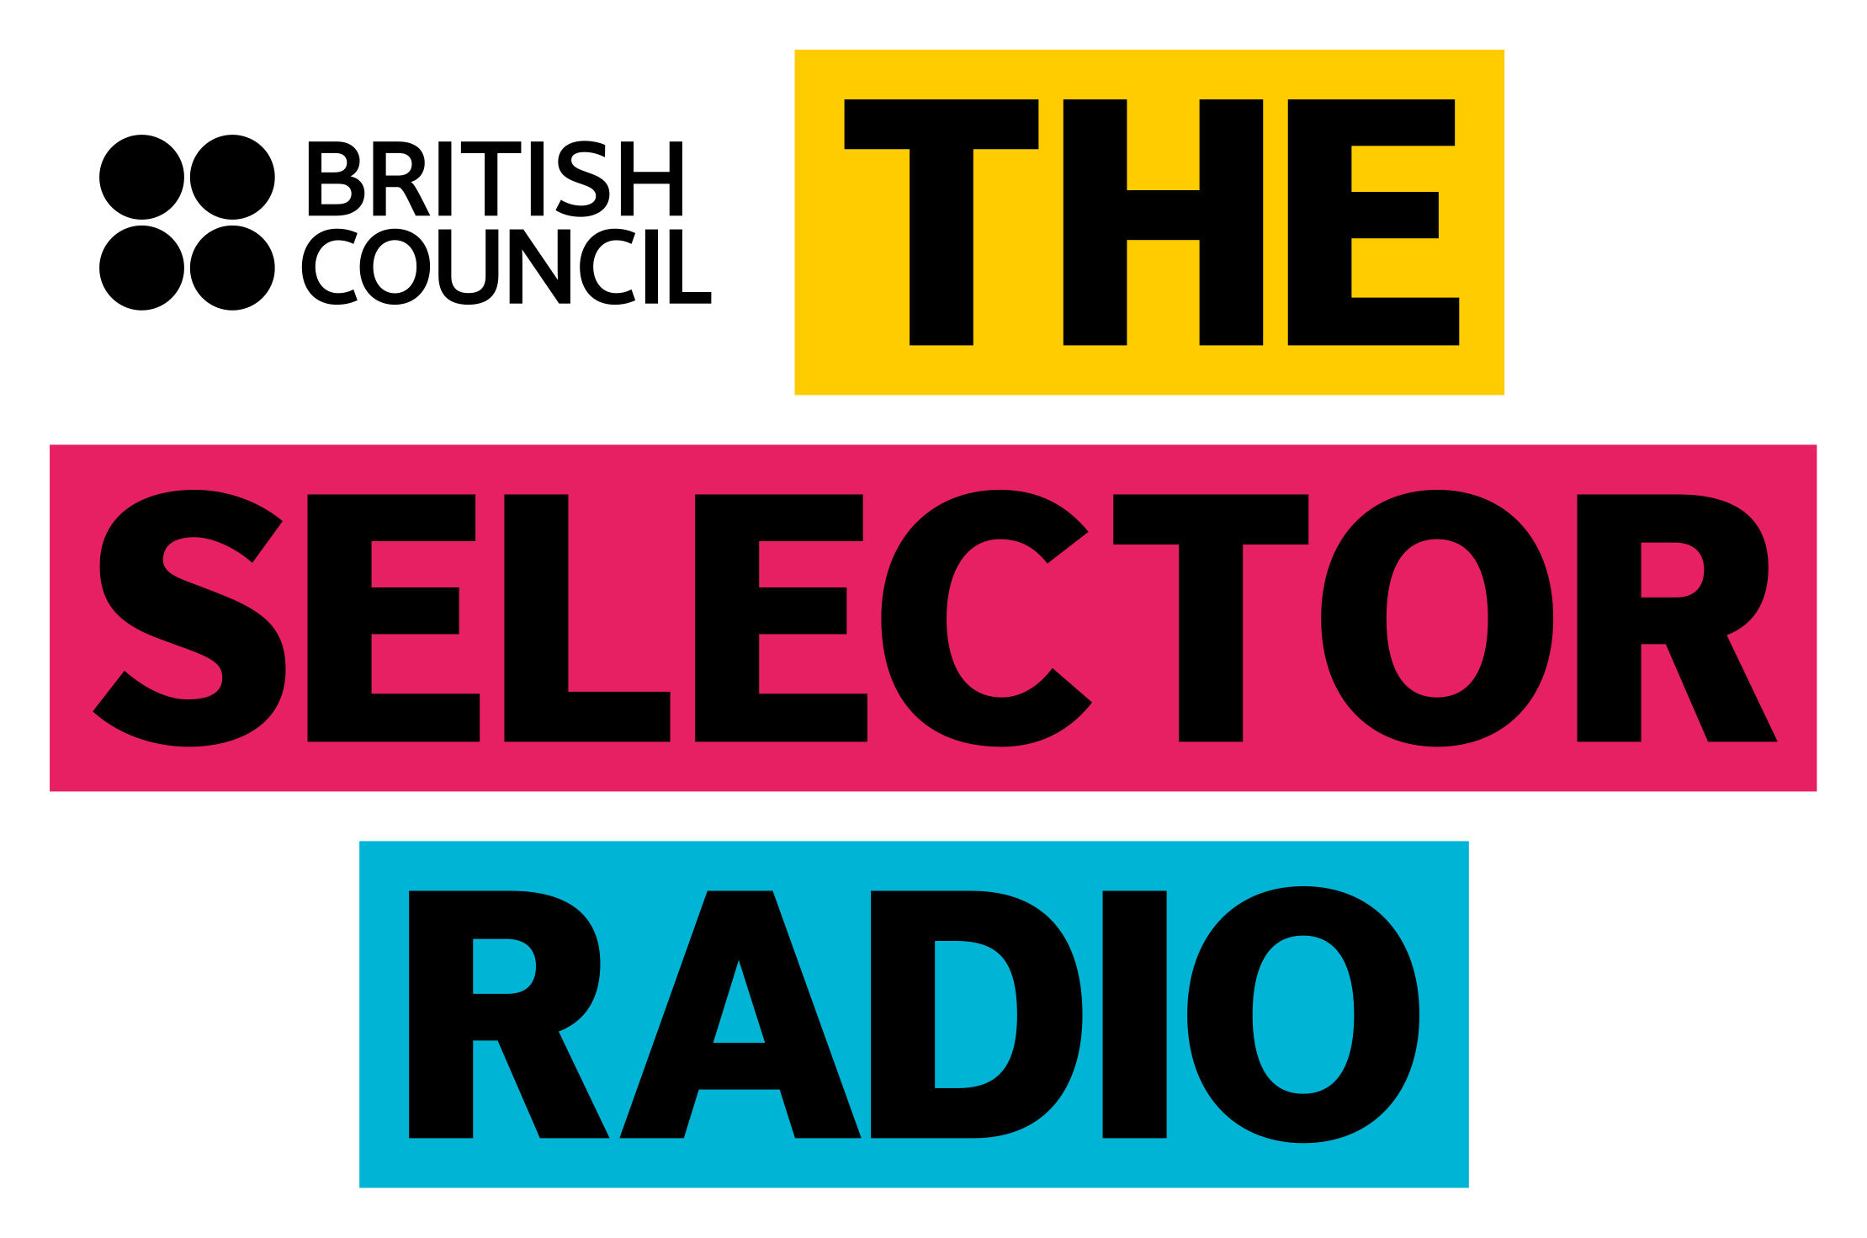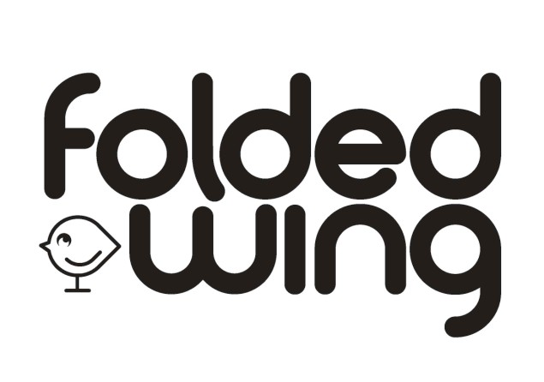

PRODUCE AND PRESENT THE SELECTOR FOR YOUR STUDENT RADIO STATION AND RECEIVE TRAINING FROM FOLDED WING
The Selector for The British Council x Student Radio Association - Application Form
Please return completed form by 9am on 7/11/16 to the following address: pete@foldedwing.co.uk

Last Name:

First Name:

Student Radio Station:

Radio Show:

University:

Course of Study:

Address:

City:

Postcode:

Date of Birth (DD/MM/YYYY):

Mobile Phone:

E-mail:

01. What have you done on radio before? What have been your best and worst bits?

02. What inspired you to become involved in radio?

03. What is it that you like about The Selector for The British Council radio programme?

04. What would you do differently on The Selector if you were producing / presenting it?

05. Tell us about an artist who we haven’t played on Selector (yet) and why you think we should be featuring them

06. What kind of radio shows and music do you like and who are your favourite presenters / artists?

Fair Collection/Privacy Notice

The British Council will use the contestants’ personal data to inform the finalists and this information will also be shared with Folded Wing and the Student Radio Association.

Contestants’ quotations captured on the application form may be used in publicity material.

Contestants’ marketing details will not be used for marketing purposes.

Your rights:

Under UK Data Protection law you have the right to ask for a copy of the information we hold on you, for which we may charge a fee, and the right to ask us to correct any inaccuracies in that information. If you want more information about this please contact your local British Council office or the Data Protection Team dataprotection@britishcouncil.org, or see our website: http://www.britishcouncil.org/home-dat a-protection.htm.

